August 2011
Healing Your Hungry Heart
Recovering from Your Eating Disorder
Joanna Poppink, MFT

“Finally—a book that speaks beyond the stereotype of eating disorders as the ‘little girl's disease,’ reaching out to women who have lived with these devastating disorders for years, and offering practical, sound, and insightful advice on how to begin, and sustain, real recovery.”
–Marya Hornbacher, author of Wasted: A Memoir of Anorexia and Bulimia

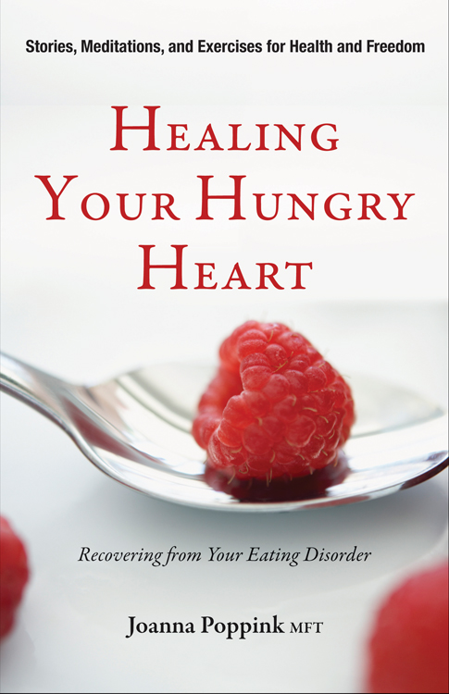
Emotional eating, binge eating, and purging, along with anorexia and bulimia have the highest mortality rates of any mental disorder. While eating disorders have long been associated with teenage girls, over the past decade a growing number of women over 35 are reportedly also suffering from these disorders.

In Healing Your Hungry Heart, psychotherapist Joanna Poppink shares the specific strategies, exercises, and activities she uses in her practice to help patients free themselves from the shame, secrecy, and isolation of living a life controlled by an eating disorder.

Poppink offers the inspiring stories of the women she has counseled, along with stories of her own personal experience with bulimia, to show how to face the challenges of these disorders, and build internal strength, acquire wisdom, and move into recovery. “A lot of fortitude, creativity, determination, and strategic thinking are required to maintain an eating disorder and all of its demands,” says Poppink. “If you have the strength and ability to sustain an eating disorder, then you have the strength and ability to move beyond it.”

Healing Your Hungry Heart is a comprehensive, step-by-step, effective recovery program that shows how to:

- Overcome triggers to emotional eating and self-criticism.
- Develop ways to feel safe and secure without resorting to eating disorder behaviors for comfort.
- Cope with tensions around relationships including friendships, romances, and family without acting out your eating disorder.
- Use your eating disorder behaviors as a metaphor to understand how you behave in other situations.
- Develop new mental, emotional, physical, and spiritual power and resiliency to cope with challenges without resorting to food or exercise rescues.

Healing Your Hungry Heart includes journaling, meditations, exercises, quizzes, and resources to support and speed the recovery process. For women struggling with emotional eating, this book offers hope, understanding, and real solutions.

“For three decades as a therapist, and now as an author, Joanna Poppink has used her personal experience with bulimia, insights into healing, empathy, and knowledge to help women recover from eating disorders. In this book, she shares stories from many of her former patients and covers diverse topics ranging from mindful contemplations on eating to an intimate discussion of sexuality. Practical, personal, and powerful!”
—Leigh Cohn, coauthor of Bulimia: A Guide to Recovery, editor-in-chief of Eating Disorders: The Journal of Treatment and Prevention

Joanna Poppink, MFT, is a licensed psychotherapist specializing in treating adults with eating disorders. She studied psychology at UCLA and the Saybrook Institute and received her Masters degree from Antioch University. She lives in Los Angeles. Visit her at eatingdisorderrecovery.com  (Photo credit: Lori Dorn) | 

Healing Your Hungry Heart
Joanna Poppink, MFT
Conari Press; Paperback/$16.05.95
ISBN: 978-1-57324-470-1
Recovery
August 2011

Available wherever books are sold or through Red Wheel/Weiser at (800) 423-7087
orders@redwheelweiser.com, www.redwheelweiser.com

MEDIA CONTACT – BOOK REQUESTS, EXCERPT PERMISSIONS, INTERVIEW SCHEDULING:
Pat Rose 415-978-2665 x101 prose@rwwbooks.com

ALL OTHER INQUIRIES:
Bonni Hamilton, 978-465-0504 x1112 bhamilton@rwwbooks.com
Lisa Trudeau, 978-465-0504 x1110 ltrudeau@rwwbooks.com

