Endorsements for Healing Your Hungry Heart: recovering from your eating disorder

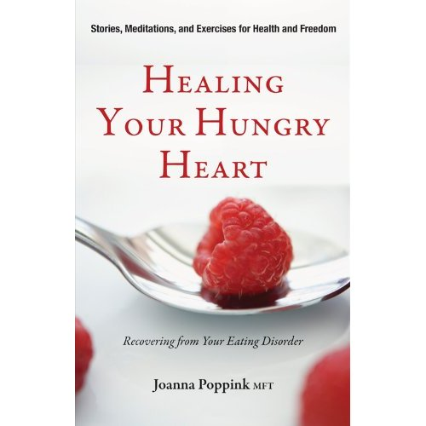

“Finally—a book that speaks beyond the stereotype of eating disorders as the ‘little girl’s disease,’ reaching out to women who have lived with these devastating disorders for years, and offering practical, sound, and insightful advice on how to begin, and sustain, real recovery.”
—Marya Hornbacher, author of Wasted: A Memoir of Anorexia and Bulimia
“If you struggle with food or body image, Joanna Poppink’s Healing Your Hungry Heart is sure to help! Through her story and those of others, Joanna assures us that true recovery is both real and attainable. This is an important addition to the recovery bookshelf.”
—Jenni Schaefer, author of Goodbye Ed, Hello Me and Life Without Ed
“Joanna Poppink’s Healing Your Hungry Heart answers two questions I frequently hear from troubled eaters: ‘How do I begin my recovery?’ and ‘What can I do to sustain it?’ Her chapter on the warning signs of an eating disorder is especially helpful to those who aren’t sure if their relationship with food is unhealthy or not. Other chapters gently guide the reader in an exploration of what is needed to recover from deregulated eating—mindfulness, self-reflection and honesty, bona fide emotional nourishment, and daily practices for skill acquisition and moving toward true fulfillment. I would certainly recommend this book to my clients and students.”
—Karen R. Koenig, LCSW, M.Ed., author of The Food and Feelings Workbook and Nice Girls Finish Fat

“For three decades as a therapist, and now as an author, Joanna Poppink has used her personal experience with bulimia, insights into healing, empathy, and knowledge to help women recover from eating disorders. In this book, she shares stories from many of her former patients and covers diverse topics ranging from mindful contemplations on eating to an intimate discussion of sexuality. Practical, personal, and powerful!”
—Leigh Cohn, coauthor of Bulimia: A Guide to Recovery, editor-in-chief of Eating Disorders: The Journal of Treatment and Prevention
“This book offers a variety of valuable tools and practical ways for those with eating disorders to nourish both their bodies and their spirits. It also offers real solutions and hope for its readers.”
—Christine Hartline, M.A., founder and director, Eating Disorder Referral and Information Center, EDReferral.com
"Eating disorders are a hidden personal ravishment in our Western culture. Those seeking a cure will find the pathway outlined in Joanna Poppink's book a strong companion on the road to recovery."
----Jonathan Flier, MA, MFT; President of the Los Angeles Chapter of the Calif. Assoc of Marriage and Family Therapists

"Joanna Poppink writes not only of the heart, but from the heart. She has been there, and shares generously of her personal struggles with bulimia. Her authenticity cannot be mistaken and gives her readers reason to be confident that she knows whereof she writes, and will not offer mere theory, nor platitudes, nor judgment. This confidence does not prove mistaken.
She has also been there as a psychotherapist--a gifted and experienced therapist, a genuine healer. This, too, comes through clearly in her book. Through many examples, exercises, and distillations of her well-earned wisdom, the author gives hope and help to women who are struggling with the pain and shame of eating disorders.
Make no mistake: this book offers no easy “fix.” The author invites her readers to undertake an admittedly difficult and often intimidating exploration of self, of the hidden meanings of symptoms and actions. She knows that one must “stay present and bear your feelings” to walk this path, and also knows how to extend help. She knows and teaches that “everything counts.” I imagine that most readers will find that they cannot work through this substantial book all at once, but will need to return to it again and again, sometimes with frustration but often, too, with joy."
Joan A. Lang, M.D.
Psychiatrist and Psychoanalyst
Professor Emeritus & Former Chair, Department of Psychiatry, Saint Louis University

"I’m delighted to recommend Joanna Poppink’s book, Healing Your Hungry Heart: Recovering from Your Eating Disorder. I was in close communication with Joanna while she was writing this book, and I know the heart and wisdom she poured into the pages.
When I read early versions of the manuscript, I knew we had a fresh new voice bringing inspiration and practical tools for eating disorder recovery.
Joanna wrote this book for mature women. I believe you will find it of great value in your own recovery and in understanding the struggles of those you love."
----Jeanne Rust, Ph.D., CEO and Founder of Mirasol, Eating Disorder Residential Treatment Center

